Susan C. Petrey Clarion Scholarship Fund
Oregon Science Fiction Conventions, Inc.
c/o Wrigley-Cross Books
1203 SE Kibling
Troutdale OR 97060

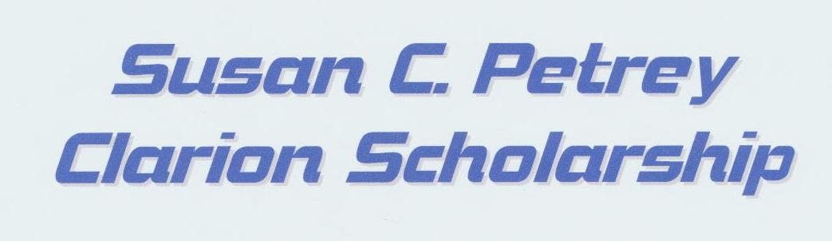

Report for OSFCI BOD Meeting – June 22nd, 2023

Attached are three attachments.

- Request for BOD to vote for disbursements. (Previously submitted at the last BOD meeting).
- OCF Request Letter. (Previously submitted at the last BOD meeting).
- Susan Petrey History (Provided to the Board on May 21st).

At the previous BOD meeting, our motion “That the OFSCI board requests the full distribution of the fund balance in Susan C. Petrey Endowment Fund of the Oregon Community Foundation to the OSFCI/Petrey checking account” was tabled. In addition, more information about the Petrey Fund (provided as Attachment 3) was requested. No one has contacted us showing any interest in becoming a Director of the Petrey Fund and we request that the Board vote on our motion at the June 22nd meeting.

At the last meeting, some concern was raised about the OCF Request Letter. The text was provided to us by Valarie Rundquist, Senior Program Officer, Endowment Partners, OCF to satisfy their requirements to transfer the funds back to the Petrey Fund.

Some concerns were raised about the transfer of funds back to the Petrey Fund.

Paragraph D of the agreement between OSFCI & OCF states: “OCF shall distribute not less than annually an appropriate percentage of the fair market value of the Fund to OSFCI…” (At this point in time, this is almost $3,000).

Paragraph E of the agreement states “OCF may make distributions from the Fund to OSCFI in addition to those required by paragraph D herein (even to the exhaustion of the fund) upon a majority vote of all of the directors of OSFCI…” (Emphasis added).

Debbie Cross
Paul M. Wrigley
Directors, Susan C. Petrey Clarion Scholarship Fund

